**Answers for the first hands-on session exercises**

**Task 5.1:** where can you find the file size for the table ‘orderdetails’?

**Answer**: Please find the file size information from the ‘database and table’ interface.

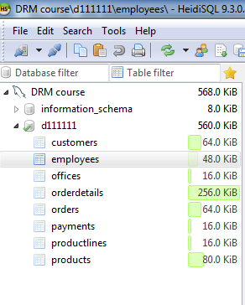

**Task 5.3:**

Please check the data of the table ‘orderdetails’, you can see that only the ***first*** 1,000 rows of the data of this table are visible, as shown in the figure below.

**Answer**: In the ‘data’ view, please find the two buttons below. These two buttons can satisfy the needs.

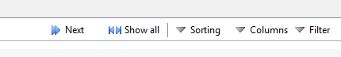

**Task 5.4:**

When browsing the data of tables, you feel the font size is small and do not like the font type. How can you change the font size and type of data?

**Answer**: Please click the ‘tool’ menu 🡪 ‘Preferences’ 🡪 ‘Text formatting’ 🡪 ‘Font’.

